**Learning Objectives:**

1. List the reasons for balancing of rotating mass
2. Describe conditions to be satisfied to achieve balance in rotating bodies.
3. Solve the mathematical equations acting on the rotating body
4. Examine the analytical results with the simulation results
5. Evaluate how change in mass and position can improve the balance of the rotating body.

### Story Outline:

The high speed of engines and other machines is a common phenomenon now-a-day. It is, therefore, very essential that all the rotating and reciprocating parts should be completely balanced as far as possible. If these parts are not properly balanced, the dynamic forces are set up. These forces not only increase the loads on bearings and stresses in the various members, but also produce unpleasant and even dangerous vibrations.[1]

The experiment involves two masses attached to a rotating shaft which is unbalanced and producing a large vibration because of centrifugal force produced by the rotating masses. The purpose of the experiment is to determine the phase angle, position and mass to balance the effect of the centrifugal forces.[1]

**Equations/formulas:**

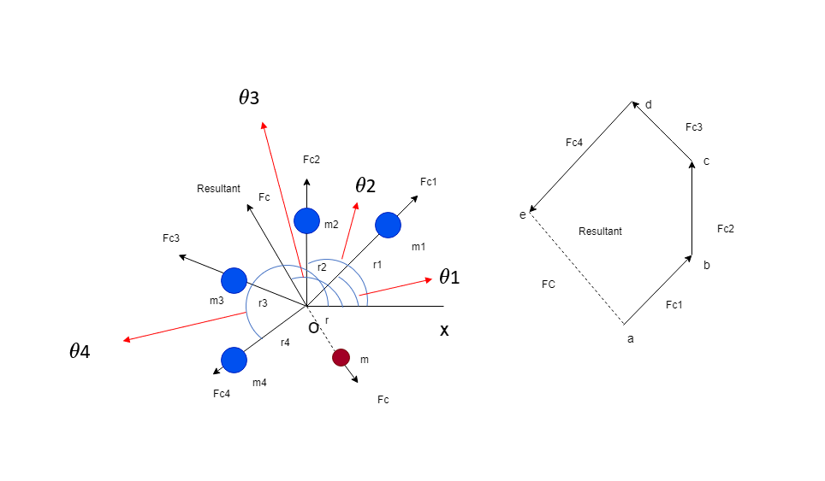

Consider any number of masses (say four) of magnitude m1, m2, m3 and m4 at distance of r1, r2, r3 and r4from the axis of the rotating shaft. Let θ1, θ3 and θ4 be the angles of these masses with horizontal line ox, as shown in figure 1. Let these masses rotate about the axis through O and perpendicular to the plane of paper, with a constant angular velocity of ω rad/sec.

The amount of balanced mass is the resultant of square root of sum of square of horizontal and vertical forces, which is acting in plane

So, the magnitude of resultant centrifugal force



The sum of horizontal component of centrifugal force



The sum of vertical component of centrifugal force



Resultant force vector Fc making inclination with horizontal, which is equals to θ



SOURCE: Theory-of-Machines-14th-ed-Khurmi-2005 (2)

REFERENCE: [1] Theory-of-Machines-14th-ed-Khurmi-2005 (2)